06th April 2018

New Series - WTCR Season starts this weekend

The WTCR – FIA World Touring Car Cup with YOKOHAMA as exclusive tyre supplier, and which starts this weekend in Morocco will enjoy a three-races-per-weekend format and will be extensively shown online and through traditional broadcasting.

With the FIA World Touring Car Championship becoming the WTCR in 2018, new rules will mean an increase in on-track action with one extra qualifying session and one extra race timetabled. While the traditional Sunday format of two quick-fire races remains, albeit with the addition of a qualifying session, racing will get underway on Saturday with what is an extra race and the first of three over the course of an event.

The Japanese Tyre manufacturer YOKOHAMA will supply 250/660R 18 size ADVAN A005 tyres slicks for use on dry and the same size ADVAN A006 for racing on wet tracks during the series.

From the season-opening WTCR Race of Morocco (7-8 April), First Qualifying and Race 1 will be available live at OSCARO.com – the website of the WTCR’s Series Presenting Partner – in Belgium, France, Italy, Portugal, Spain, Switzerland and the USA.

With the exception of those countries and territories where live broadcasting agreements are in place with local networks, namely Fox Sports (Latin America), J SPORTS (Japan), M4 (Hungary), OSN (MENA) and 2M (Morocco), First Qualifying and Race 1 will be broadcast on Facebook as part of plans to extend the reach of the series. This coverage will also promote the broadcasting of Races 2 and 3 on television. In addition, for most races, Free Practice 1 and Free Practice 2 will also be broadcast on Facebook worldwide with no restrictions. Eurosport, meanwhile, will continue to broadcast one qualifying and two races live each weekend just as it did in the WTCC era with Fox Sports, J SPORTS, M4, OSN and 2M doing the same. Eurosport will also show delayed Race 1 highlights.

The 2018 WTCR season gets underway in Marrakech, Morocco, from 7-8 April with the first of 10 weekends across four continents.

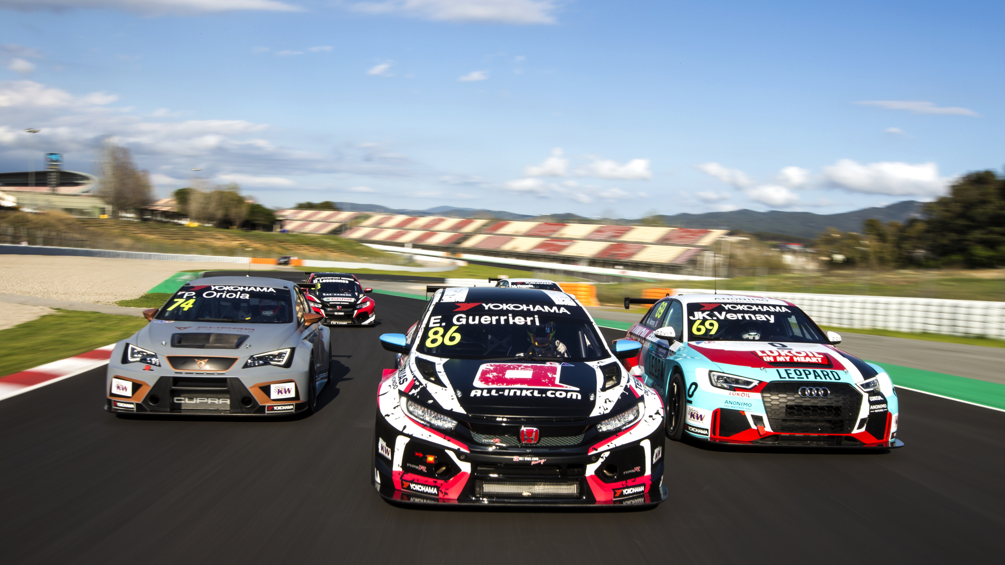
WTCR 2018

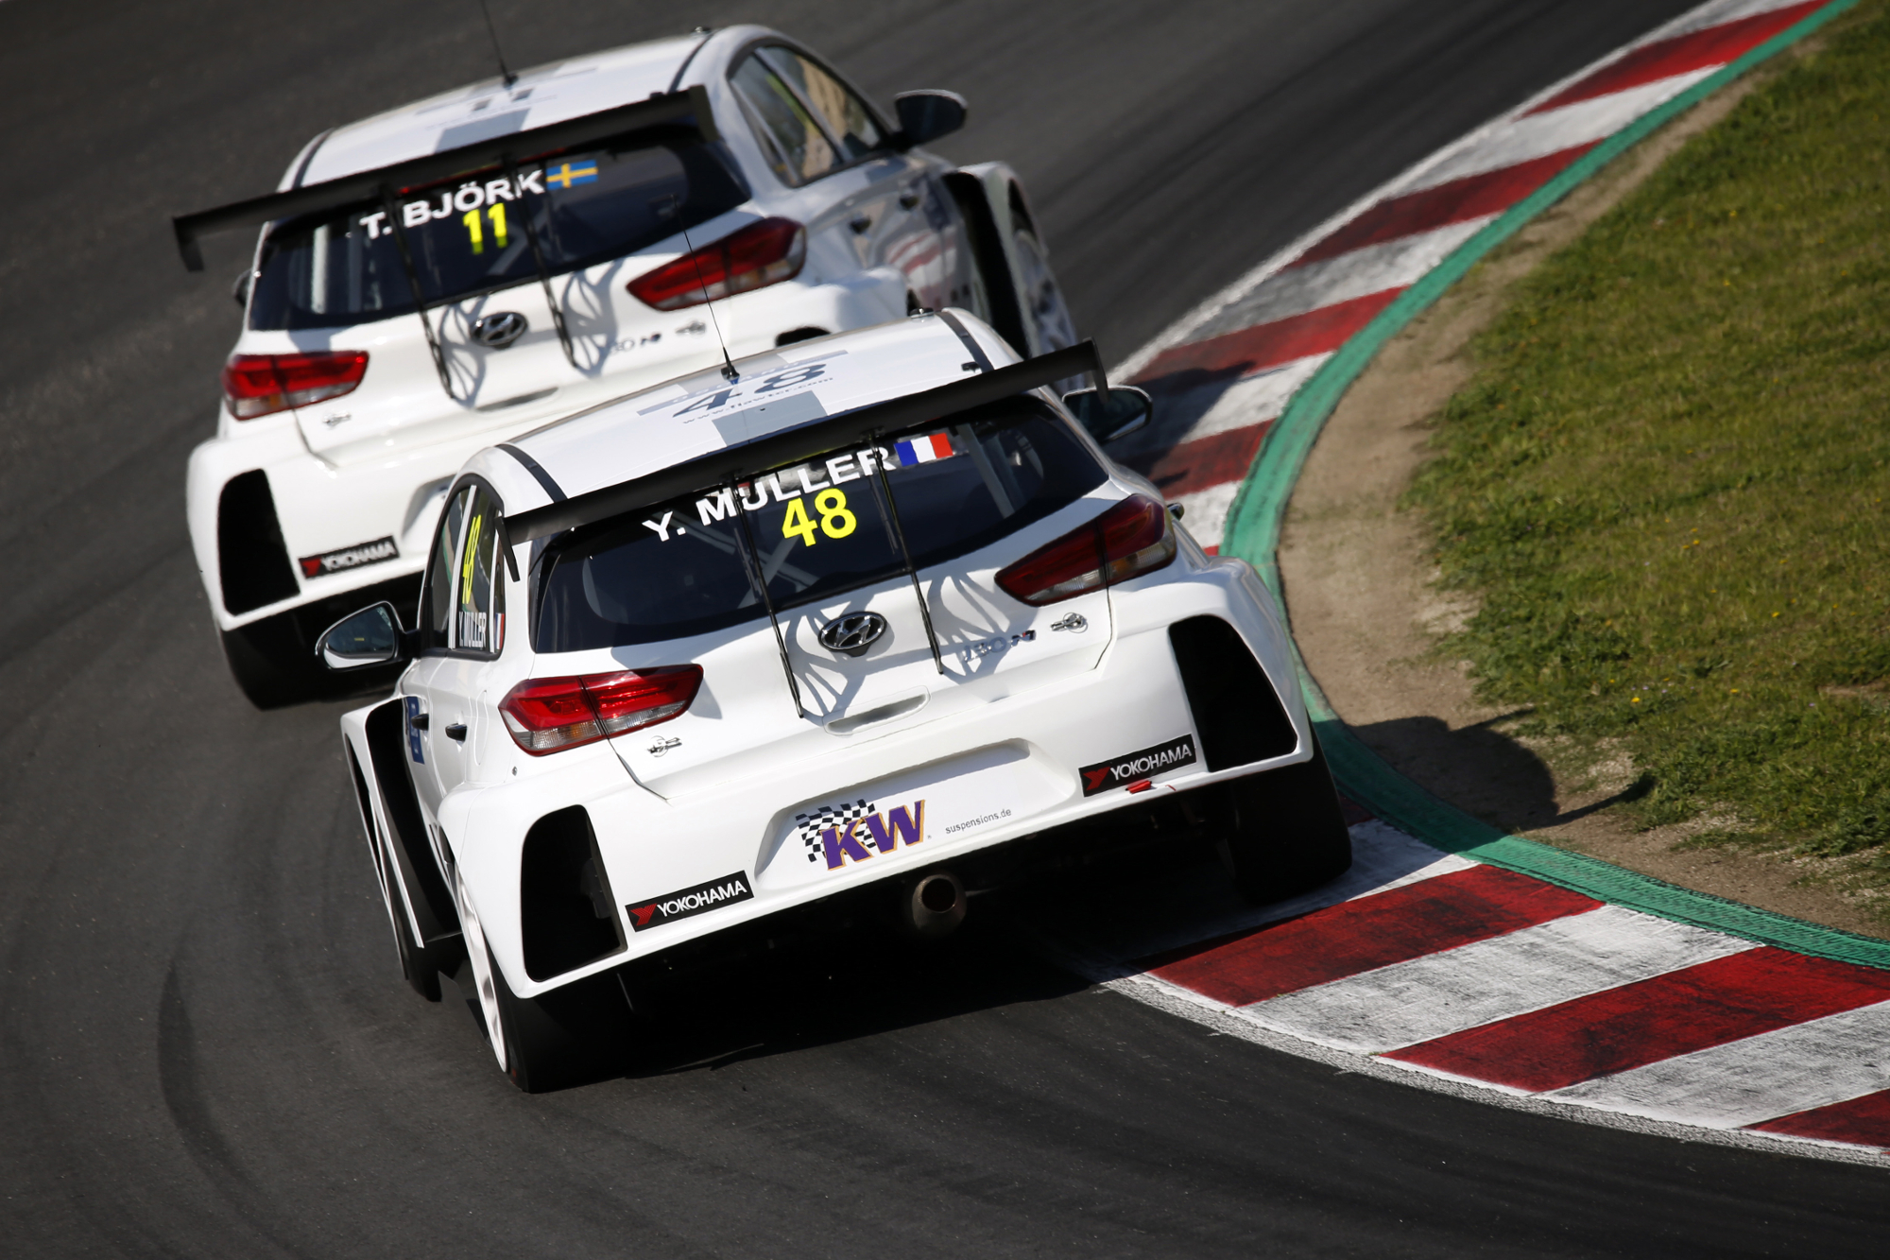
WTCR_Thed Bjork and Yvan Muller

